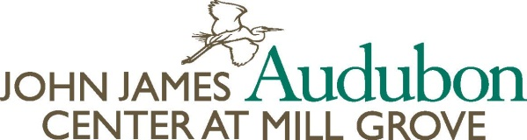 Rev. 7/13
1201 Pawlings Road, Audubon, PA 19403 Phone 610-666-5593 Ext. 109 Fax: 484-831-5305
cashley@audubon.org

Volunteer Application

Date:

Name:

Home Address:

Home Phone: Work Phone:

Cell Phone: Emergency Phone:

E-Mail Address:

Day (s) and Times Available:

Time Preferred: Mornings: Afternoons: Evenings: Anytime As Needed:

Describe any previous volunteer experience you have had:

Do you have any special skills or hobbies that may be useful in your work as a volunteer?

Are your volunteer hours due to a community service obligation?

If yes, how many hours must you complete?
Is this for high school, college, or other? (Please specify)

Please check all of the opportunities that interest you:

Museum Collection’s Assistant Gardening Trail Maintenance Publicity/Newsletter

Photography Gift Shop Special Events Museum Tours

Environmental Education Assistant Other (Specify):

Art Committee: Annual Art Show, museum exhibitions and more

If you are age 17 or below, you must print this form and send it to Mill Grove with a parent or guardian’s signature below. If you are age 13 or below, you can only volunteer with a parent or guardian:

Signature of parent or guardian: _________________________________________________

Please fill out the form and either send back as an attachment via e-mail to cashley@audubon.org or print off and either fax or mail to: John James Audubon Center at Mill Grove, 1201 Pawlings Rd, Audubon, PA 19403. Fax: 484-831-5305 Attn: Carrie Ashley. A background check is required for all persons age 18 and over before you can officially begin volunteering. The paperwork will be provided after your initial interview.

