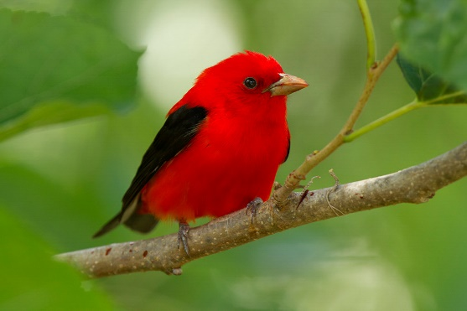
Photo credit: Audubon Photography Awards / Linda Steele

Southeastern Pennsylvania Municipality Workshop Mini Grants
Connecting People to Places

We’re happy to announce that three $1,000 mini grants will be awarded to selected applicants.

Grant Goals:
To support municipal level projects/programs designed to improve climate resilience and maintain healthy watersheds for people, birds, and other wildlife.

Projects submitted for funding must identify specific goals and objectives that can be effectively measured to evaluate success and be action-oriented.

They must also meet at least two of the following criteria:
- Take an integrated approach to solving a problem
- Create a platform for ongoing public engagement
- Include one or more municipal partners
- Increase connected habitat that provides ecosystem services
- Demonstrate the potential for environmental impact on a landscape scale

This opportunity is open to municipalities that attend the Southeastern Pennsylvania Municipality Workshop.

Application Deadline is October 15. Grants will be awarded in early November. Please complete attached Project Development Worksheet (no more than 3 pages total).

Contact Valerie Peckham at vpeckham@audubon.org with questions.

Funding for grants has been made possible through a project of Audubon Pennsylvania and the Elmwood Park Zoo.

